Southern Tier Chapter of
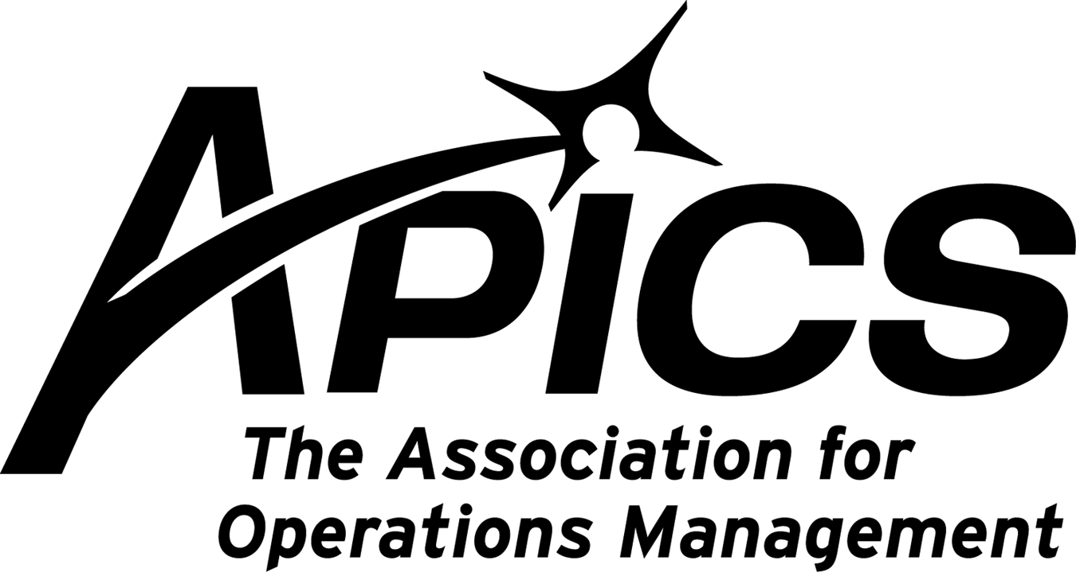
www.stapics.org

“Advancing productivity and innovation and competitive success.”

NO JULY DINNER MEETING

Message from Don Sheldon, VP of Education

You will find an announcement in this monthly newsletter about the new certification test being offered for people whose
certification has expired. For people who are interested self-assessment materials will soon be available from APICS. This
Datachem CPIM Skill Gap Assessment product will cost $199 for members and $220 for non-members. This tool will assess candidates’ strengths and weaknesses to better point them toward necessary areas of study. The program will contain 800+ questions from which candidates can choose by topic area, MPR, DSP, ECO and SMR, by subtopic or questions not previously reviewed. Candidates will be provided with a score at the end of the program. This product will be available soon on the APICS bookstore. Watch for it.

APICS CPIM RECERTIFICATION EXAM

APICS is pleased to announce that a new certification product has been developed this year. The APICS Certified in
Production and Inventory Management (CPIM) Recertification Exam was approved by the APICS Leadership Team
in February 2010.

APICS CPIM Recertification Exam
The APICS CPIM Recertification Exam provides a unique opportunity to individuals whose CPIM credentials have
expired and previously were required to retake all five CPIM exams. Instead, candidates now can renew their
certification by taking one exam. This exam is a limited-time offering and will be available only through December 31,
2011. The three-hour exam will consist of 120 multiple-choice questions. The test will include 30 items taken from each of
the following modules: Detailed Scheduling and Planning, Master Planning of Resources, Execution and Control of
Operations, and Strategic Management of Resources. There will be no un scored items on this exam.

First APICS Recertification Exam
Candidates will have the opportunity to take a paper-and-pencil exam at the 2010 APICS International Conference &
Expo in Las Vegas, Nevada. The exam is scheduled for October 17, 2010. The next opportunity to take the exam
will be in December 2010.

Who Is Eligible?
To be eligible for the APICS CPIM Recertification Exam, candidates must have obtained their CPIM before the year
2000 and have expired CPIM credentials.
MWV Mail - APICS: Grist for newsletter & website https://mail.google.com/a/mwv.com/?ui=2&ik=b0da0c5a6b&view=pt&se...
1 of 2 6/18/2010 2:57 PM

Eligibility Process and Cost
Candidates will be required to go through an eligibility process that will verify that the candidates previously earned
the APICS CPIM designation. Applications will be reviewed, and candidates will be notified if they qualify. Once the
application is approved, candidates will be able to register online or by phone with Pearson VUE. There is a
non-refundable application fee of $150. The cost of the exam is $425 for members and $575 for nonmembers.
Candidates who are unsuccessful on their first attempt can retake the exam at a discounted rate of $350.

Visit apics.org/recertification to learn more about the program, exam delivery, costs, application information and
study options to prepare for the exam.

APICS Releases Influential APICS Operations Management Body of Knowledge
(OMBOK) Framework to Public

Previously complimentary only for APICS members, the APICS OMBOK
Framework provides organizations and their employees a dynamic resource for
effective operations management

Chicago, Ill. (June 25, 2010)—APICS The Association for Operations Management,
the global leader in supply chain and operations management certification,
education, and membership, released to the public its trusted and widely-recognized
APICS Operations Management Body of Knowledge (OMBOK) Framework as a
complimentary resource. The APICS OMBOK Framework defines the scope of the
operations management profession and provides a dynamic resource and framework
to understand operations management today and for years to come. It previously
was available only for APICS members.

The APICS OMBOK Framework is updated annually and builds on more than 50
years of operations management knowledge. It provides a dynamic resource to
understand the state of operations management today and a framework that evolves
to reflect changes in the profession.

“With its release to the public, the APICS OMBOK Framework can become an
essential reference tool to all businesspeople as supply chain and operations
management becomes a more visible function throughout the enterprise,” said
APICS CEO Abe Eshkenazi, CSCP, CPA, CAE. “APICS is enthusiastic to make
available this fundamental and easy-to-understand guide.”

The APICS OMBOK Framework connects the knowledge and competencies
required to be effective in the operations management field to the daily work of
professionals around the globe. It provides operations and supply chain management
professionals with an easily comprehendible reference to review industry concepts
or explore them for the first time.

The APICS OMBOK Framework includes two appendices that feature tables
illustrating the relevancy of the APICS OMBOK Framework to specific job titles,
including supply chain manager and materials manager, and to industries outside
manufacturing, such as distribution, health care, retail, utilities, and hospitality.
Information about the APICS OMBOK Framework, second edition, can be found at
www.apics.org/ombok.

About APICS The Association for Operations Management
APICS The Association for Operations Management is the global leader and premier source of
the body of knowledge in operations management, including production, inventory, supply chain,
materials management, purchasing, and logistics. Since 1957, individuals and companies have
relied on APICS for its superior training, internationally recognized certifications, comprehensive
resources, and worldwide network of accomplished industry professionals. For more information,
visit www.apics.org.
Congratulations to Don Sheldon!

Our own Don Sheldon has been awarded the Master Instructor Level for CPIM Instruction, and the Associate Instructor Level for CPCS and Lean Instruction. This certifies that Don has completed APICS’s Instructor Development Program and also recognizes his experience in teaching these review classes. This is another example of why it’s a great idea to take APICS classes from Southern Tier APICS!

CAREER ARTICLE
By Deborah Walker, Certified Career Management Coach

“So Why Should We Hire You?”

If you are currently in a job search chances are you've been asked that question already. Undoubtedly, it is the most feared interview
question, but one of the most common. It pays to be ready to answer it. helps to understand that the question is an invitation for you to
sell yourself. This is a good thing. No one is going to hire you until they have been sold on you. This is your chance to state your value tothe prospective employer. The best way to answer this question is to prepare for it like a sales person. There are three steps to selling yourself with confidence.

1. Know your product “YOU.”

Every successful salesperson knows their product inside and out. They understand the benefits of each product feature. In like manner,
you must be able to articulate your transferable skills. First, take inventory of your skills. Make sure the skills you focus on are in demand for the position you seek. Next, take stock of the times of crisis when you've used those skills to solve problems. Finally, ask yourself what your employer got out of your successes on the job. Did you save time or money, increase revenue, improve service or increase productivity? Your success stories carry more weight when you can quantify the results. These success stories make up your selling points.

2. Know the challenges of the position.

Before you can tell them why they should hire you, you must understand their current challenges. After all, you couldn't sell a car unlessyou knew understood how it was to be used. Until you know what challenges go with the position you won't know which of your sellingpoints to talk about. To learn about their challenges you must ask them. In the beginning of the interview ask your interviewer, “What challenges do you see as most significant for this position in the first six months?” Take careful note of his/her response. You will learn the “hot button” issues that you must sell you.

3. Match your skills to their challenges.

Here is where you get to sell yourself. Once you understand the critical skills they need for the job you simply share with them your
success stories of when you have faced similar problems and how you solved them. Be sure to include the all-important benefit your
company received. Start off your value statements with phrases like:

“I found a significant savings opportunity when...”

“My team gained efficiency when I discovered how to...”

“My boss achieved his quarterly objective when I...”

Remember, even if you don't get asked “why should we hire you” it is the underlying question and the point of the whole interview. Job
interviews are your chance to sell your skills, talents and expertise. Before your next interview practice good salesmanship and prepare
to sell yourself like a pro.
~~~~~~~~~~~~~~~~~~~~~~~~~~~~~~~~~~~~~~~~~~
Deborah Walker, Certified Career Management Coach
Read more career tips and see sample resumes at:
www.AlphaAdvantage.com

Your 2010-2011 Board of Directors

President / VP Education Dave Gardner dgardner@akraturn.com
VP Membership / Website Lee Schechter lschechter@stny.rr.com
Executive VP / Director of Finance Steve Whited steve.whited@mwv.com
Director of Education Don Sheldon dsheldon@stny.rr.com
Publicity / Marketing / Programming Michael LoSapio Michael.losapio@synergyresources.net
Marketing Director Kelly Norieka Kelly.norieka@lmco.com
Secretary Deb Unkel deb.unkel@raymondcorp.com

Southern Tier APICS
PO Box 1107
Binghamton NY 13902-1107

